The role of trust in legal entities in enhancing interest of individuals in politics
[Name of students]
[Name of professor]
[Date of submission]

Table of Contents
1.0 Introduction 3
1.1 Background 3
1.2 Aims and objectives 3
1.3 Structure of assignment 4
2.0 Conceptual Framework 4
2.1 Literature review 4
2.1.1 Trust on legal entities and interest in politics 4
2.1.2 Role of trust on entities in enhancing interest in politics 5
2.1.3 Impact of trust on legal entities on interest level of individuals in politics 6
2.2 Conceptual Framework 6
2.3 Hypothesis 6
3.0 Methodology 7
3.1 Data collection Method 7
3.2 Variables and their measurement 7
3.3 Data analysis method and instrument 8
4.0 Data analysis 8
4.1 Descriptive Statistics 8
4.1 Correlation Analysis 9
4.2 Regression Analysis 10
5.0 Discussion and Conclusion 11
References 13

1.0 Introduction

1.1 Background
Voting right is power of a democratic nation accompanied by freedom of expression, and free from any political pressure or influence Whittington, Kelemen and Caldeira (2011). In a democratic country, political interest of a person heavily depends on expectations, and their choices may also be influenced by family, friends, environment and also personal experience and opinions Levinsen and Yndigegn (2015). In this regards, a study conducted by Catterberg and Moreno (2006) found that political trust level of individuals is positively associated with the performance of government, democratic attitude, social capital, and well-being. Similarly, political trust level in some democratic country has been declining since two decades, which is attributed to promises made by democratic government, and then decisions truly do not reflect interest or expectations of peoples.
Experience and personal opinions of individuals regarding politics is based on performance of government. It means performance of government can effectively form a positive opinion in individuals (Healy, Malhotra and Mo, 2010). Similarly, interest in politics is enhanced by expectations of individuals from the government, legal system, and parliament. Meanwhile, interest in politics increases understanding of a person and he became well aware of his rights, and can also make informed decisions when casting vote. Therefore, in order to create interest of individual in politics, his trust on legal entities is integral.

1.2 Aims and objectives
Aim of this research is to analyze role of trust on legal entities in enhancing interest of individuals in politics. Meanwhile, legal entities refer to parliament, legal system, police, and EU parliament. Therefore, following research is about to determine does trust on legal entities enhance or encourage interest level of individuals in politics. In order to achieve this following research questioned have been formed;
- What is relationship between trust on legal entities and interest level in politics?
- What is impact of trust on legal entities on the interest level in politics?
- What are implications of results?

1.3 Structure of assignment
Section 1: Introduction is first section of the assignment which introduce to research and highlights aim of the research. This section also provides research questions, for which assignment is carried. Conceptual Framework is second section of the assignment, in which academic literature is reviewed specifically previous work authors related to topic of assignment. Conceptual framework is developed in this section which will outline overall concept and purpose of the study visually. Lastly, hypothesis is also developed into this section based on aim of research and conceptual framework. Methodology is third section, in which research methods are briefly described and justified. Data analysis is fourth section of the assignment, in which data is analyzed and interpreted. The last section of assignment is discussion and conclusion, in which assignment will be concluded based on secondary literature and findings from data analysis.

2.0 Conceptual Framework

2.1 Literature review

2.1.1 Trust on legal entities and interest in politics
Legal entities are governmental organizations that have legal power and obligations to perform as per their legal rights and obligations. These entities are non-for-profit organizations, and are developed and structured to support country’s counter-action against anti-social elements to enforce law and order (Adriano, 2015). Obligations of legal entity remain within their own jurisdiction, and it may and may not depend and have effect on another government organization. Considering the UK parliament and EU parliament, both are legal entities but are separate from each other, where one rules within the area of EU and UK parliament rules within the area of UK (Mendel, Fyfe and Heyer, 2017). Similarly, legal system is referred to the process of interpreting and enforcing the law. Court and police are within legal system, where court rules and police enforce law within the country. These are legal entities which are believed to have impact on the country and individuals particularly.

2.1.2 Role of trust on entities in enhancing interest in politics
A study conducted by Bauer and Fatke (2014) investigated relationship between direct democracy and political trust. Theoretically, it is presented that political trust is enhanced by greater availability of direct democratic rights, because perception of citizens can be enhanced by increasing perception that legal entities or political authorities can be controlled. The result of study suggests that there is positive relationship between direct democracy and political trust among citizens. In same manner, study of Catterberg and Moreno (2006) found that political trust level of individuals is positively associated with the performance of government. In contrast, it is also argued that trust in entities may and may not enhance interest of individuals in politics. It is because, trust of citizens develops when they experience about the wrongdoing of an institution. However, a legal entity could be right and may be perceived not right. Hence, in such situations, distrust among citizens tends to rise. Therefore, Blind (2007) argues that trust of a person on parliament develops when his expectations and interest are met accordingly. In contrast, another’s person’s interest and expectations may have been forgone; hence his trust level may be lower than former case.

2.1.3 Impact of trust on legal entities on interest level of individuals in politics
Lower level of trust on legal entities can lead to lower compliance with rules and regulations. Because citizens become aware that there are not protected and becomes risk-averse, avoid investment, innovation and employment opportunities. Therefore, it is does not affect the social system and structure of the country, but it also affects financial conditions of the country (Bauer and Fatke, 2014). It is determined that trust of people on legal entities becomes a source of satisfaction and ease. Because they know that they are protected by legal system of the country. In this context, it is can be stated that trust of people on legal entities should also enhance the interest in politics. Hence, it can be determined that trust on legal entities can have positive and significant impact on politics interest of individuals.

2.2 Conceptual Framework
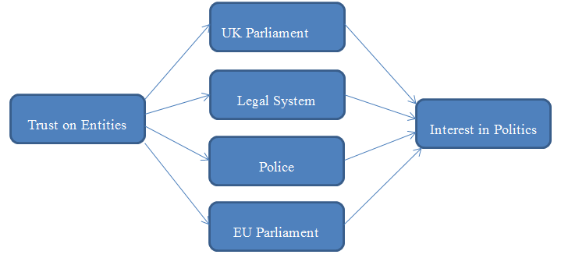

2.3 Hypothesis
H₁: Trust on Parliament positively and significantly enhances interest of individuals in politics.
H₂: Trust on Legal system positively and significantly enhances interest of individuals in politics.
H₃: Trust on Police positively and significantly enhances interest of individuals in politics.
H₄: Trust on EU parliament positively and significantly enhances interest of individuals in politics.

3.0 Methodology

3.1 Data collection Method
For data collection, secondary data collection method was used since it was feasible and there was huge dataset. Data was collected from European social survey, and it was only source of data collection (Bell, Bryman and Harley, 2018). Secondary data collection method was used because it is feasible and researcher can be access to wide range large related and unrelated data set which can further help in conducting research. However, such data also carries some limitations such as data might have been manipulated to get desired outcome, and things may change over time hence data may become unreliable to use.

3.2 Variables and their measurement
There are five variables of the study, four of them are independent and one variable is dependent. These four independent variables include; trust on parliament, trust on legal system, trust on police, and trust on EU parliament. Meanwhile, dependent variable is interest in politics. These variables were measured on Likart-scale questionnaire through survey.

3.3 Data analysis method and instrument
In order to analyze data, descriptive analysis was performed to get overview of data, such as mean of responses, minimum and maximum values. Furthermore, to analyze relationship between variables, Pearson’s correlation was used. Similarly, data was run on multiple regressions model to determine impact of independent variables on dependent variable. For data analysis, SPSS statistical software was used to analyze data.

4.0 Data analysis

4.1 Descriptive Statistics
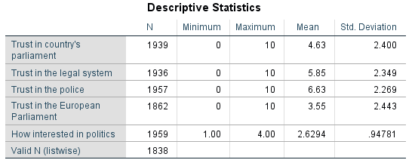
Referring to descriptive statistics results above, it is determined that mean response to pertaining to trust on parliament, minimum response was 0 and maximum response was 10. Whereas, 0 is represents not trust at all, and 10 represents complete trust. Meanwhile, mean response to is 4.63 with standard deviation of ±2.4. It implies that individuals somehow have trust on parliament of the country. On the other hand, mean of trust on legal system is 5.85 with standard deviation of ±2.349. It indicates that on average respondents have good trust on legal system of the country, and mean response can also vary by ±2.349. Hence, it may be 8.1 or decline to 3.5 respectively. Meanwhile, mean response on trust on police was 6.63 with standard deviation of 2.269. The result indicates that peoples have more mean trust on police than on legal system and UK parliament. On the other hand, mean response to trust on European parliament is 3.55 with standard deviation of ±2.44. It indicates that mean respondent had least trust on parliament of European Union. Furthermore, referring to interest in politics, it has mean response of 2.6 with standard deviation of ±0.94. It was scaled on four points; hence it indicates that on average peoples had good interest in politics.

4.1 Correlation Analysis
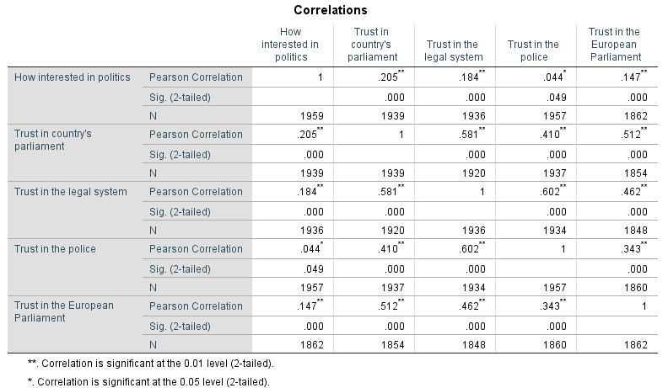
Referring to result of Pearson correlation, it is determined that interest in politics and trust on country’s parliament has positive but weak relationship since coefficient is 0.205 with sig value of 0.00. Similarly, relationship between interest in politics, trust in legal system, trust in police, and trust in European Union is positive weak but statistically significant since coefficient of their relations are 0.184, 0.044 and 0.17 with sigh value of 0.00 respectively (Sekaran, and Bougie, 2016). Therefore, it can be stated that there is positive weak but statistically significant relationship between trust on country’s parliament, interest in politics, trust in legal system, trust in police, and trust in European Union.
Furthermore, considering the cross relationship between independent variables, then it is determined that trust in country’s parliament, trust in legal system, trust in police, and European Union is positive strong and also statistically significant. It implies that if trust of citizen’s increase on parliament then their trust on legal system, police and EU parliament will also improve. Similarly, trust on legal system and police is also strong positive which indicates both are strongly correlated with each other. On the other hand, trust on EU parliament also has good positive relation with the UK parliament and legal system. Hence, it indicates that there improvement in UK parliament trust and legal system of UK will also increase trust of people on EU parliament.

4.2 Regression Analysis
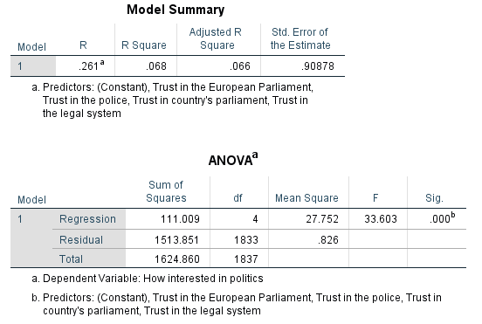
Referring to model summary and ANOVA table, R is 0.261 which represents relationship among variables which are included in the model. Relationship between variables is positive, and r square is 0.068, which shows that only 6.8% of dependent variable is predicted and explained by independent variables. It means that there are other certain variables which tend to predict interest of peoples in politics. Furthermore, ANOVA table shows sig value is 0.000 that is less than alpha 0.05; hence it can be interpreted that model is significant. It means predication and explanations of the model are statistically significant (Saunders, 2011).
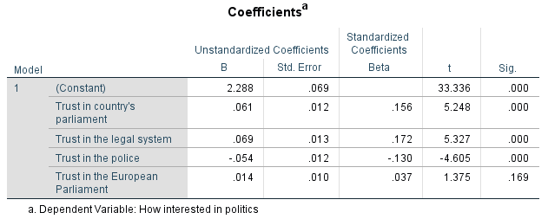
Referring coefficient table, it is can be interpreted as that one unit of change in trust in parliament, legal system, police, and EU parliament will bring change of 0.061, 0.069, -0.054, and 0.014 respectively. It means positive change is expected if there is positive change in trust in parliament and legal system only since results of these variables are statistically significant and positive. On the other hand, results suggests that if trust of person increases in police by one unit then it decrease interest level of individual in politics by -0.054. Lastly, trust in EU result is not statistically significant which means result is due to error or by chance. Hence, there may not be impact of trust in EU parliament on interest of person in politics.

5.0 Discussion and Conclusion
It is found in secondary research that political trust of individuals is positively associated with the performance of the government, democratic attitude, social capital, and well-being of society (Catterberg and Moreno, 2006). Meanwhile, performance of government and personal experience person may increase interest of individual in politics. Furthermore, lower level of trust on legal entities can lead to lower compliance with rules and regulations. Hence, there interest in politics will also decline. In this context, it can also be argued that increased trust on legal entities should also enhance interest level of individuals in politics. Meanwhile, findings from data analysis section suggest that two hypotheses are accepted and two are rejected. Since, trust on Parliament positively, and trust on legal system positively and significantly enhances interest of individuals in politics; because, result is positive and statistically significant. On the other hand, third hypothesis rejected is trust in the police have negative impact and is statistically significant. Lastly, trust on EU parliament also has positive impact but is not statistically significant.

References
Adriano, E.A.Q., 2015. The natural person, legal entity or juridical person and juridical personality. Penn St. JL & Int'l Aff., 4, p.363.
Bauer, P.C. and Fatke, M., 2014. Direct democracy and political trust: Enhancing trust, initiating distrust–or both?. Swiss Political Science Review, 20(1), pp.49-69.
Bell, E., Bryman, A. and Harley, B., 2018. Business research methods. Oxford university press.
Blind, P.K., 2007, June. Building trust in government in the twenty-first century: Review of literature and emerging issues. In 7th Global Forum on Reinventing Government Building Trust in Government (pp. 26-29). Vienna: UNDESA.
Campos, C.F., Hargreaves Heap, S. and Leite Lopez de Leon, F., 2016. The political influence of peer groups: experimental evidence in the classroom. Oxford Economic Papers, 69(4), pp.963-985.
Catterberg, G. and Moreno, A., 2006. The individual bases of political trust: Trends in new and established democracies. International Journal of Public Opinion Research, 18(1), pp.31-48.
Healy, A.J., Malhotra, N. and Mo, C.H., 2010. Irrelevant events affect voters' evaluations of government performance. Proceedings of the National Academy of Sciences, 107(29), pp.12804-12809.
Levinsen, K. and Yndigegn, C., 2015. Political discussions with family and friends: exploring the impact of political distance. The Sociological Review, 63, pp.72-91.
Mendel, J., Fyfe, N.R. and den Heyer, G., 2017. Does police size matter? A review of the evidence regarding restructuring police organisations. Police Practice and Research, 18(1), pp.3-14.
Saunders, M.N., 2011. Research methods for business students, 5/e. Pearson Education India.
Sekaran, U. and Bougie, R., 2016. Research methods for business: A skill building approach. John Wiley & Sons.
Whittington, K.E., Kelemen, R.D. and Caldeira, G.A., 2011 Overview of Law and Politics the Study of Law and Politics. In The Oxford Handbook of Political Science.

